DAQ Data Translation Program

**Overview:**

The DAQ Data Translation Program facilitates the translation of plain text data to the mechanical team’s preferred csv file format. During this process it computes RPM data, translates analog readings to sensor outputs, and averages those sensor outputs down to defined polling rates. The program is installed via a python program distributed amongst GTOR team members, and, once installed, the program is able to update itself at the users request.

**How to Use:**

The program features a basic tkinter interface consisting of a couple of buttons and labels. The program features two main screens, home and the data translation tool, the first of which is pictured below.

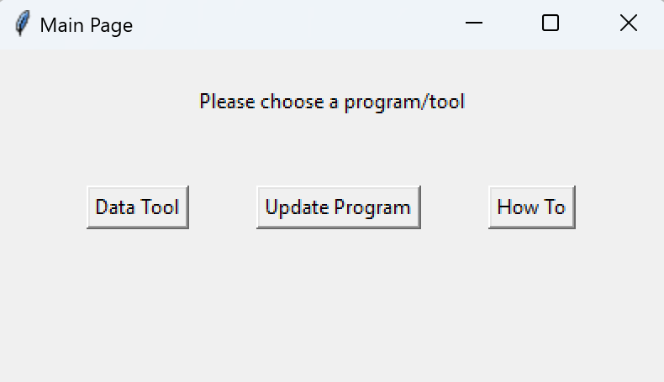

Figure 1 – Home Page: This page allows users to either open the data tool, update the program, or open the general how to guide.

If the user elects to update the program upon initial startup the tkinter GUI will close and a succession of terminal commands will be executed to redownload all the program files, scan them for their python libraries, and install/update all python libraries. The user is required to restart the program after performing such an operation.

If the user elects to open the how to guide a simple notepad window will open the HomeScreen.txt file packaged in the program’s Guides folder. This document contains basic information about the program and is updated on a regular basis to reflect any changes to the program.

If the user elects to open the data translation tool the following window will open.

Figure 2 – Initial Data Translation Tool Window: This is what the user sees immediately after pressing the Data Tool button.

This screen features a how to guide specific to the operation of this section of the program in addition to a choose file button. The choose file button opens a file explorer window to the current file path, allowing users to navigate to their desired data file located on the Mech E drive. Once selected the screen will appear as follows.

Figure 4 – Data Tool Screen With File Selected

After selecting a file the user is required to download it to their local storage to enable faster data handling (if it’s already downloaded (filepath is from the C drive) this step is not needed). This could be changed in the future, but the incredibly slow wifi in the SCC led to the decision to lock this down. After downloading the file, the user can select it from their installation folder which will bring up the following screen.

Figure 5 – Fully Fledged Data Tool Screen

This screen allows the user full access to all the Data Translation Tool’s features. Process Data will create a .csv file based on the parameters detailed in config (downloaded automatically in the previous section), Edit Config will open the config file in a notepad window to allow for customization, and Calculate Hertz Info will analyze the file and report a collection of statistics about it. The use of these features will not be further detailed in this guide as their specifics are likely to change with future updates.

**How It’s Made:**

The Data Translation Tool is made entirely in python. The DAQ.py file imports a succession of dependencies located in subfolders which each play a vital role in the program’s ability to function. Each of these files are thoroughly commented and it is recommended for DAQ members to familiarize themselves with them before building additional functionality into the tool.

**Rules and Regulations:**

In order to add some consistency to the backend of this program a few formatting rules have been laid down.

1. Have all imports at the top of the file with a 1 line gap between the last important and the first comment, line of code, or quite literally anything. This is necessary as the installer loops through each file until it finds the first empty line.
2. Have all gui elements controlled by their relevant functions. This means that functions should be passed their necessary args (like a file path or whatev) in addition to the main data tool page and the new tkinter page created for the function call. This helps break the code up for easier debugging.
   1. Note how the only things passed to DataTranslator.translateData are the filepath of the data, the progress bar page, and the original data processing page. Look inside the DataTranslator.py file to see the creation of its labels and progress bar.A close-up of a logo

      Description automatically generated

**Update Log:**